

SOFTWARE DESIGN SPECIFICATION
Project Name (Code)

– Hanoi, Sep 2025 –

Table of Contents
I. Record of Changes 3
II. Software Design Document 4
1. High Level Design 4
1.1 Software Architecture 4
1.2 Package Diagram 4
1.3 Database Design 5

I. Record of Changes
Date | A*  M, D | In charge | Change Description
*A - Added M - Modified D - Deleted

II. Software Design Document

1. High Level Design

1.1 Software Architecture
[The content of this section includes the overall architectural diagram which includes the sub-systems and/or components, the external systems (if any), and the relationships (communication messages) among them. You need also provide the explanation for each of the diagram components (modules, sub-systems, external systems, etc.)].
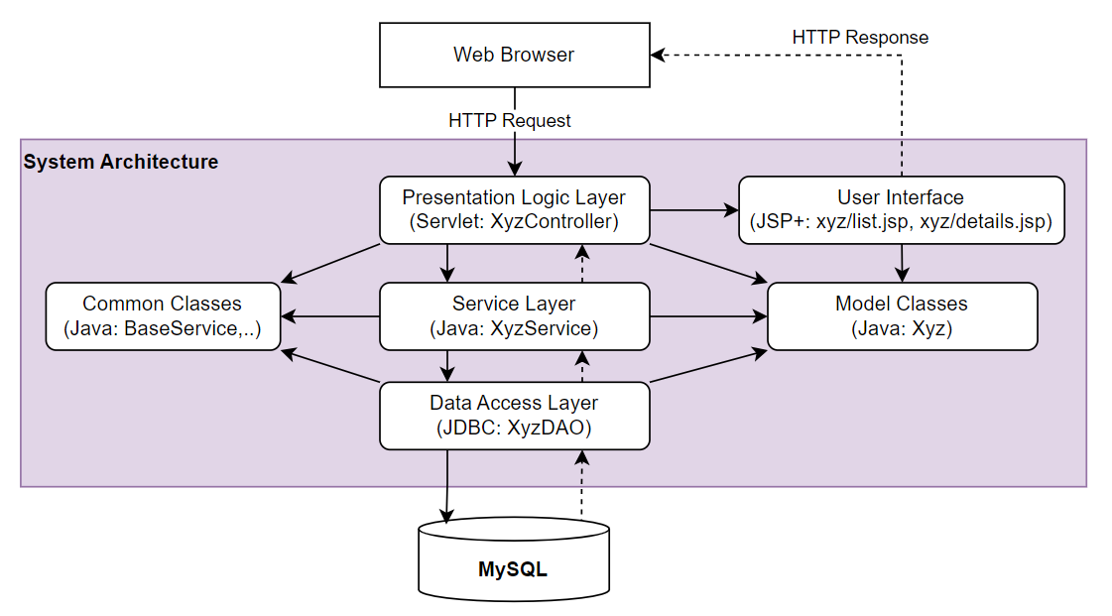-

1.2 Package Diagram
[Provide the package diagram for each sub-system. The content of this section including the overall package diagram, the explanation, package and class naming conventions in each package. Please see the sample & description table format below]
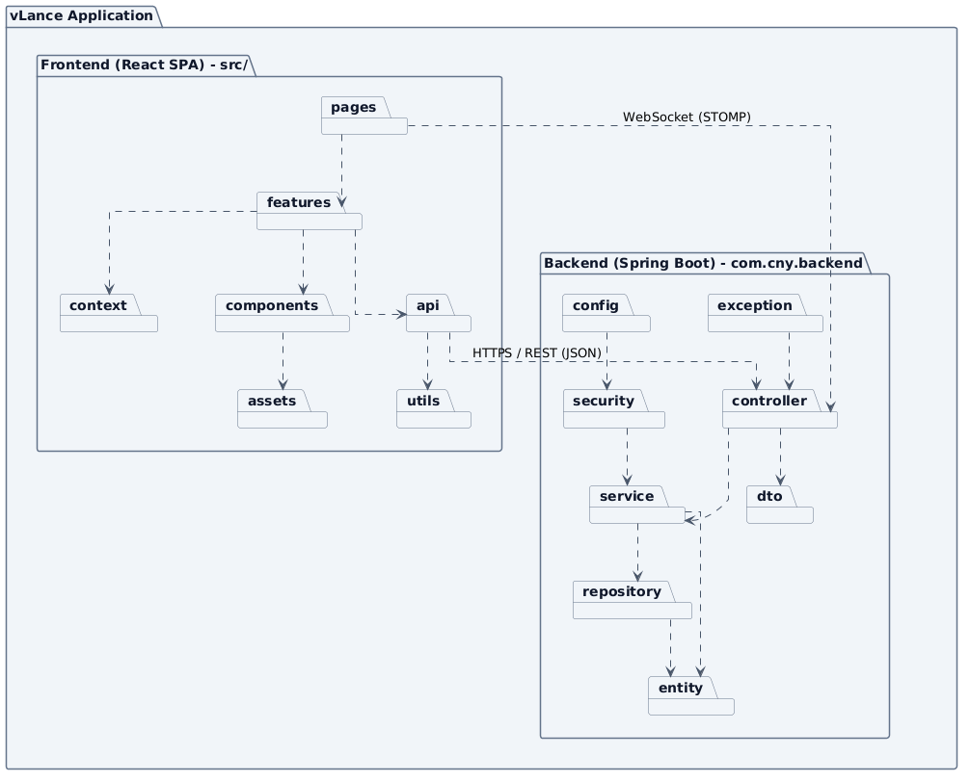
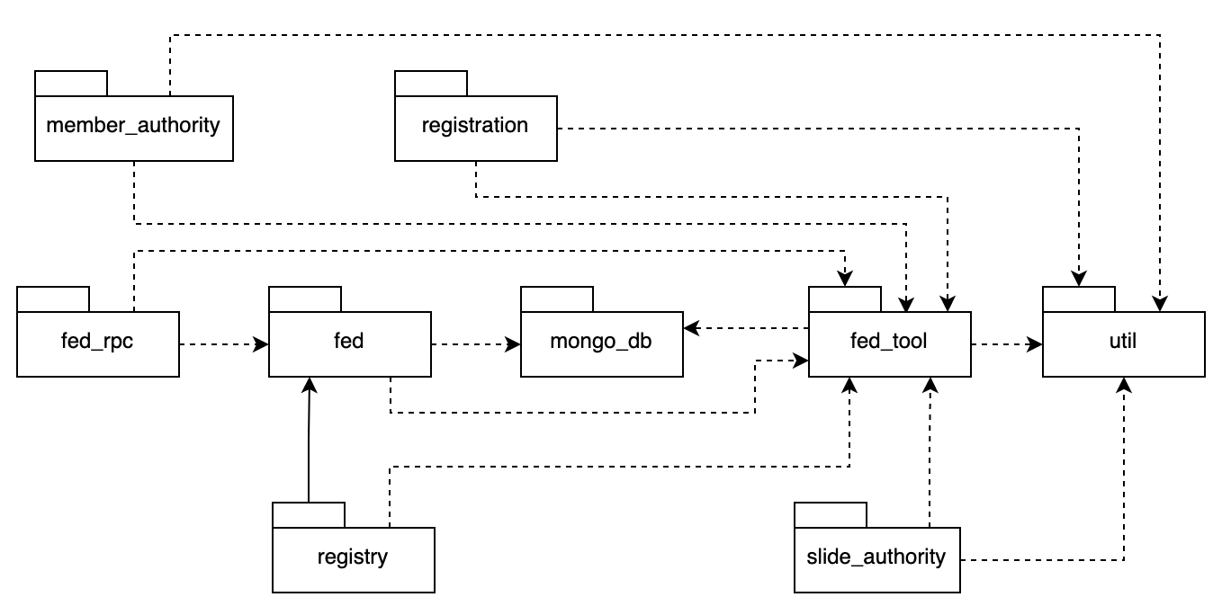
Package descriptions
No | Package | Description
01 | Member_authority | <Description of the package>
02 | registration | <Description of the package>
03 | …

1.3 Database Design
[Provide the files description, database table relationship & table descriptions like example below]

1.3.1 table_name1
[Provide brief description of the table here]
[Provide the detailed table fields description using below table format
* PK~Primary Key; FK~Foreign Key; UN~Unique; NN ~ not null
No | Field | PK | FK | UN | NN | Description
01 | <field_name1> |  |  |  |  | <Description of the field_name1>
02 | <field_name2> |  |  |  |  | …
..

1.3.2 table_name2
…

